PROJECT MANAGEMENT and System Development

Insights from Industry Talk 2

Report content:

Professional Trajectory: An Overview of the Speaker’s Experience and Journey

Skill Comparison: Academic Expectations Versus Industry Requirements

Bridging Strategies: Approaches to Close the Identified Skills Gap

Group Insights and Strategic Outlook: Members’ Reflections and Future Plans

GROUP MEMBERS:

Name | Matric Number
Khalid | A23CS4042
Abdulrahman Mohammed | A25CS0003
Nasma Mutasim Ibrahim Mohamed | A25CS5054
Basma Mutasim Ibrahim Mohamed | A25CS5053
Mohammed Rahbab Chowdhury | A25CS0013


Speaker Profile:

Speaker: TS. HJ. ABDUL ALIM BIN ABDUL MUTTALIB – Head of Technology and Innovation of Serunai Commerce Sdn Bhd
Experience:

Over 10 years in software project management across fintech and e-commerce sectors: -

Guided multiple development teams through agile transformation.

Experience with cross-functional teams and clients, managing projects across both traditional Waterfall and Agile setups.

1.Professional Trajectory: Speaker’s Experience and Journey
TS. HJ. Abdul Alim Abdul Muttalib has over a decade of experience in software project management, primarily within fintech and e-commerce sectors. His career journey reflects a shift from traditional Waterfall models to Agile frameworks, where he guided multiple development teams through digital transformation initiatives. The speaker emphasized that system development is not merely an academic subject but a practical discipline that demands continuous adaptation to technological and market changes. His key message “If you fail to plan, you are planning to fail” highlights the critical role of structured project management in real-world tech environments.
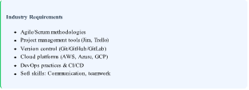
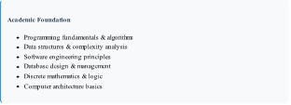
Academic Expectations Versus Industry Requirements:

Recent studies highlight the evolving nature of skill requirements in technology fields. According to Chen and Lee (2024), there exists a significant disparity between academic curricula and industry expectations, particularly in areas of practical implementation and collaborative workflows. The gap is not merely technical but encompasses project management competencies that are increasingly vital in modern software development environments.
Smith (2023) further emphasizes that while universities excel at teaching theoretical foundations and algorithmic thinking, industry prioritizes "ship-ready" skills that contribute immediately to project timelines and business objectives. This includes familiarity with collaborative tools, understanding of deployment pipelines, and ability to work within defined project management frameworks.
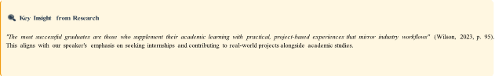

Bridging Strategies:
The disconnect between academia and industry stems from several factors: the rapid pace of technological change, differing priorities (theoretical depth vs. practical application), and the evolving nature of software development methodologies. However, universities and students can adopt proactive strategies to bridge this divide.

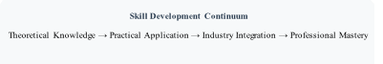

Brown (2024) suggests a three-pronged approach: curricular integration of industry tools, industry-academia partnerships for project collaborations, and student-led initiatives to develop supplementary skills. Many institutions are now incorporating agile methodologies, version control systems, and cloud computing basics into their core curriculum, responding to industry feedback about graduate readiness.
For students, integration involves a conscious effort to apply academic concepts in practical contexts through personal projects, open-source contributions, hackathons, and internships. The speaker particularly emphasized the value of GitHub portfolios as tangible demonstrations of both technical capability and project management understanding.

Members’Reflections and Future Plans:

Nasma Mutasim:
“The talk emphasized adaptability and lifelong learning as essential in a fast-changing tech field. I plan to build a T-shaped skill set by developing deep expertise in data science or machine learning while broadening my skills through teamwork, open-source projects, and mentorship, treating my degree as a foundation for continuous growth.”

Khalid:
The industry chatter has changed my perception of success in computer science. I was initially looking at computer science sucsolely cess in terms of theoretical achievement in class, but now I recognize that effective project and team management skills are just as important. My four-year plan will span three categories: the initial development and comprehension of basic programming knowledge and Git; hands-on experience with the use of the agile method during internships; and finally, managing large-scale projects that require both programming knowledge and team management acumen.

Basma MUTASIM:

“Industry talk 2 changed my view of computer science. It made me realize that it is not just about computers but about solving problems in any field. I plan to create meaningful impact across diverse industries by aligning my studies at UTM with the latest market demands.”

Abdulrahman:

“I learned from the industry talk that success in computer science requires strong planning, communication, and flexibility alongside technical skills. Over the next four years, I aim to improve my skills through group projects and internships. And by combining academic learning with practical experience, I will be better prepared for the industry challenges.

Rahbab:
The industry talk highlighted the importance of viewing software development as a complete system rather than isolated coding tasks. I learned that planning, documentation, and understanding system requirements play a critical role in project success. In the future, I aim to strengthen my system design and development skills by applying structured methodologies in coursework and building practical projects that reflect real industry workflows.
REFERENCE:
Brown, A. (2024). Bridging the academia-industry gap in software education.
Journal of Computing Education, 12(3), 45–67.
Chen, L., & Lee, M. (2024). Disparities in skill expectations between universities and tech industries. International Journal of Technology in Education, 8(1), 112–130.
Smith, J. (2023). From classroom to boardroom: Preparing CS graduates for agile environments. Computing Research Review, 15(2), 88–104.

